A new IT system for Personal Trading Requests is now in place, replacing the previous one.
For your first submission, please follow these steps:
1. Register your account at https://eform.avenue.limited/

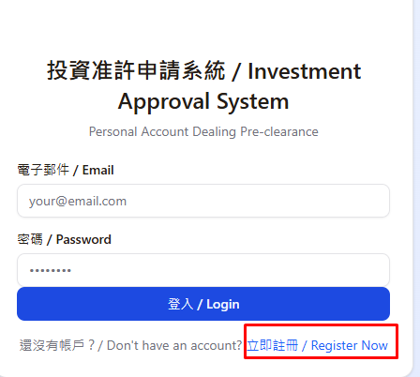

2. To create a new request, select "Submit New Request".
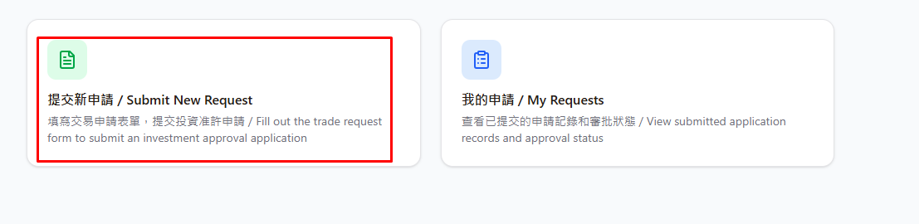

3. Fill in the required information accordingly.
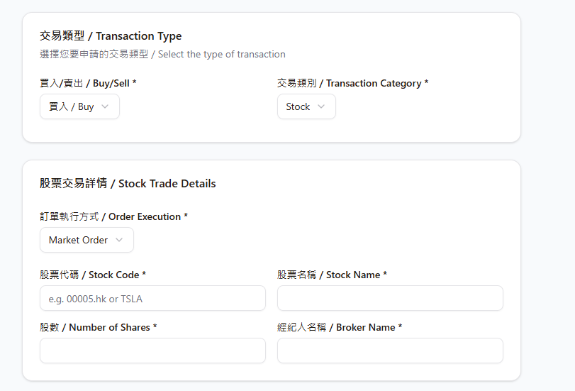
4. Please review the Company Policy before finalizing your submission.
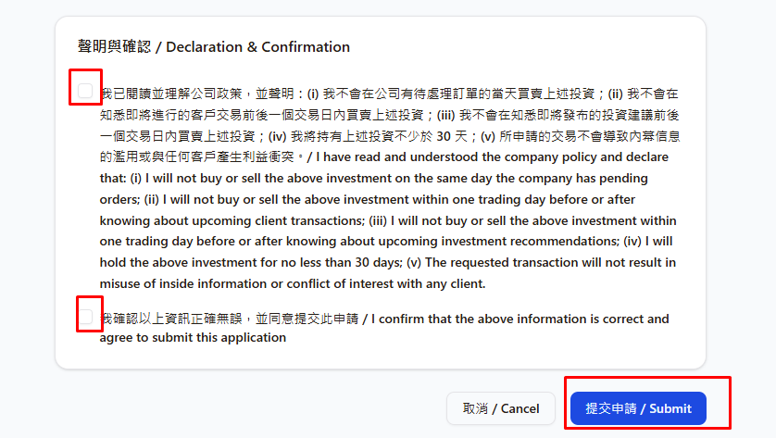
5. You will receive an approved or rejected email & you can track the status of your requests under "My Requests".
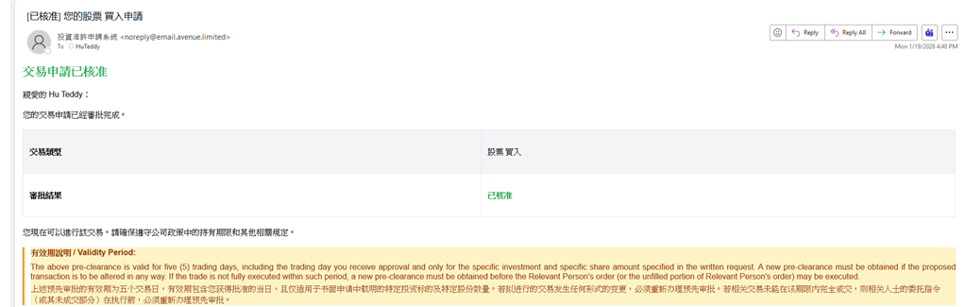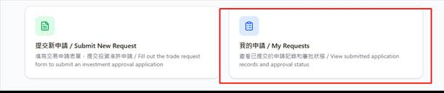

Please use this system for all future trading requests.

Should you have any questions, feel free to contact the Compliance team.

